**The revelation of a limited article**

Benjamin To

[CMN288 - Communication and Social Media - F2023](https://courses.torontomu.ca/d2l/home/779095)

Dr. Kisha McPherson

September 2023

The Article:

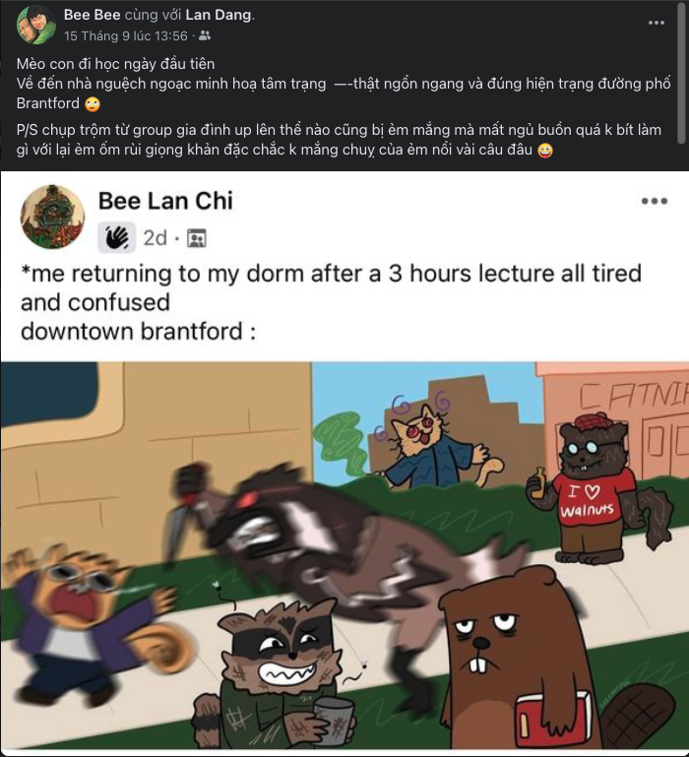

Translation of the status:

My girl first day at school

Coming home, doddles illustrate the mood – so messy and true to the current state of Brantford’s streets.

P/s: This is from a family group and I’m sure she will not be happy about this post when find out.

Abstract:

This is a post on Facebook of a Vietnamese mother whose daughter go to Canada for study. The mother shares a post of her daughter which supposed to be visualized only to a group of family members. Her daughter study in Brantford and accommodate in dormitory which is right in the middle of Brantford downtown. The post demonstrates the chaos of downtown Brantford under the daughter’s gaze and show the instability of her.

**Privacy is affected**

The daughter not intended to public her feeling but she in need to share it with her belove family members so that why she tries to use Facebook’s privacy setting to segment her audiences. However, she can not handle over her mother action, following Marwick, A. E., & boyd, danah. (2014) “While teens can control what they post on their profiles by using different privacy settings, they have far less control over what friends post about them or how their friends’ practices shape how they’re seen” (Network privacy: How teenagers negotiate context in social media). As we can see from this, privacy in social media has a very fragile barrier. This led to the problem that although you can have control over your post, you cannot keep track of how each of your friends manage their privacy setting. Once you post something on social media, it belongs to the world. You cannot control who has access to it or how someone might use it. Even your profile is kept private and as in this specific case: limited group setting.

Moreover, the mother may think that this is cute, but her daughter may not think so. As stated “Personal interactions are often visible regardless of whether teenagers themselves posted the information ([boyd, 2014](https://journals-sagepub-com.ezproxy.lib.torontomu.ca/doi/10.1177/1461444814543995#bibr3-1461444814543995)). Parents look over teens’ shoulders at home. Friends tag them in embarrassing photos. Exes post angry rants, inappropriate photos, or worse. Even grandmothers think nothing of sharing old baby photos.” (Network privacy: How teenagers negotiate context in social media). The mother’s thought has affected her daughter’s privacy and may also damage the trust of her daughter. Sharing the cute moment of her daughter may bring up to the mother a lot of conversation with her friends on Facebook about the cutie of their children. These conversations aggravate the problem which already damaged the daughter emotional far enough. This is because of parents always seem to recognize their children as they always kids. However, specific in this case, the daughter may feel ashamed, and this post can possibly be brought up as a joke toward her friends. This may lead to several consequences: the daughter may never share her true feeling with her mother anymore as she will be aware of her mother action, causes a decrease in intimacy in the relationship between mother and child. As a study in 2016 (<http://yardi.people.si.umich.edu/pubs/Schoenebeck_FamilyTechRules16.pdf>), Alexis Hiniker, Sarita Schoenebeck and Julie Kientz did a survey about family rules technology use. “Oversharing” is one of the most concerns of many children on social media about their parents’ post without their permission.

This is the truth that children are unlikely to gain control over their parents’ posting habits. But there is still a scope for a conversation about what constitutes fair sharing, and each family will draw its lines differently.

**Minimize the revelation!**

All of this come from people choices, so that the change in people’s consciousness will be the best solution overall. Parents should always be aware of their own children’s choices. Parents teach children about their ownership, teach them to respect privacy, like knocking the door. However, when they post or share a content without the children’ opinion, it seems that they are not respecting their self-ownership, privacy or opinion. When parents concern more about their children privacy and understand in a way that will gain trust from their children. They will find out that: Although the children do care about their own privacy, their first instinct would be to share stuff with that person. It not only strengthens the relationship among parents and children but also an effective way for parents to get up with their son and daughter.

# Otherwise, children must use a lot of method to cover their “existence” on social media away from their parents. Such as, “social steganography” (covered writing) or to render posts inaccessible in a performative manner or esoteric techniques, etc. These has been mentioned in Networked privacy: How teenagers negotiate context in social media.

# Overall, parents should pay more attention to their actions, especially on social media as it may be harmful for their kid. Children have their own right to make decision over anything related to their privacy and most importantly, privacy on the Internet is much more complicated and abstracted than it may seem.

# References:

# Marwick, A. E., & boyd, danah. (2014). Networked privacy: How teenagers negotiate context in social media. New Media & Society, 16(7), 1051–1067. H

* **Alexis Hiniker, Sarita Y. Schoenebeck , Julie A. Kientz (2016). Not at the Dinner Table: Parents’ and Children’s Perspectives on Family Technology Rules**